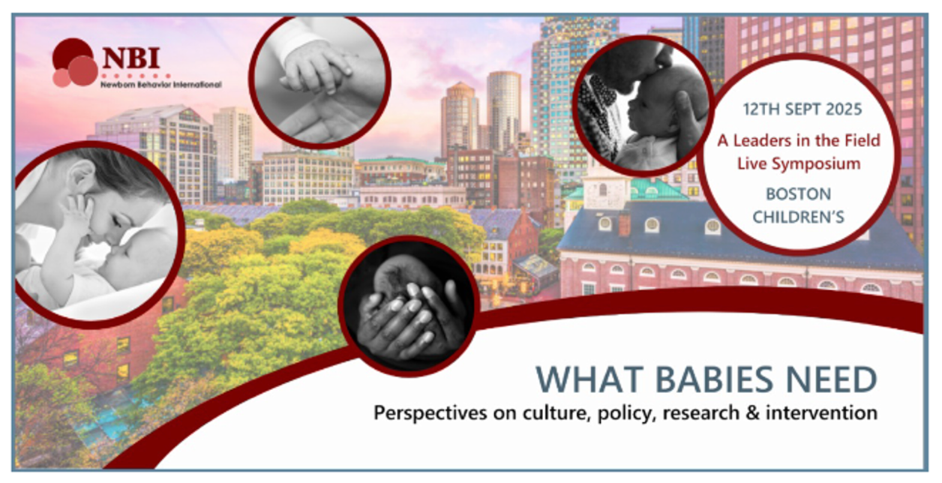
Register now and join us!

Dear Colleagues,

Please join us for a special live Leaders in the Field event on Friday, September 12, at Boston Children's Hospital. We'll learn from the following luminary speakers in the fields of Early Relational Health and Infant Mental Health (ERH/IMH):

- Jack Shonkoff, MD
- Ed Tronick, PhD
- Catherine Monk, PhD
- Linda Gilkerson, PhD, LWS
- Carmen Rosa Noroña, LICSW, MS. Ed., IECMH-E®

A moderated panel discussion will follow.

Our speakers each bring unique perspectives and experiences ranging from neuroscience research to relational interventions to public policy. A panel discussion will elevate central themes and contextualize the Neonatal Behavior Assessment Scale (NBAS) and the Newborn Behavioral Observations (NBO) system within the ERH/IMH ecosystems.

To assist us with planning, please register as soon as possible. Space is limited. The symposium begins at 1pm ET and is approved for 4 hours of CME/CEU credit across many disciplines.

Questions? Reach out to institute@childrens.harvard.edu

